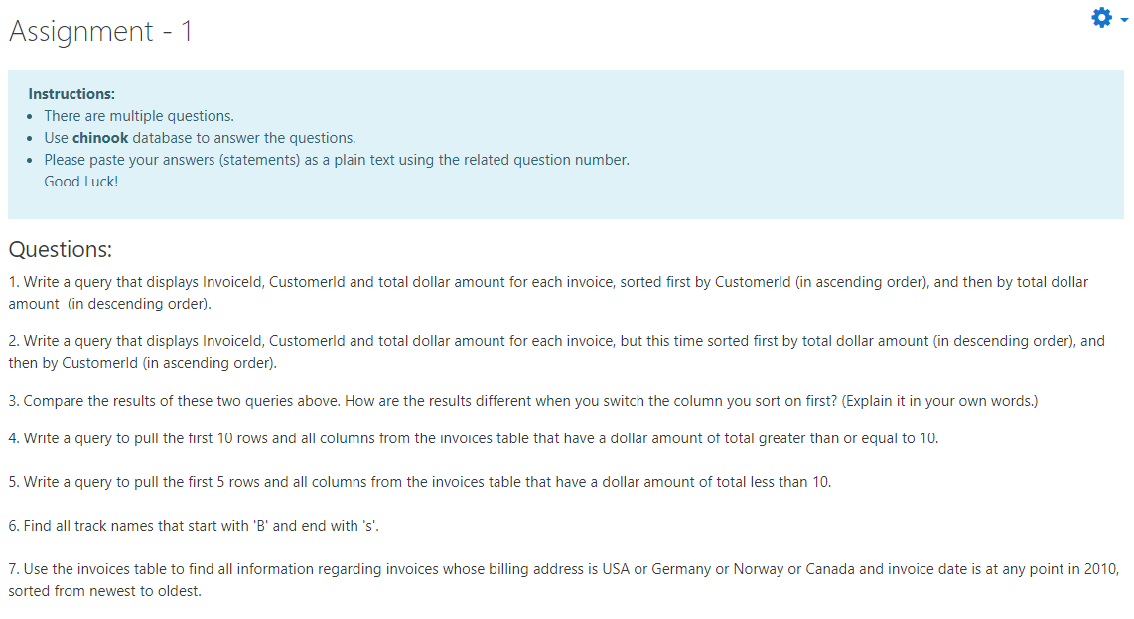

1) SELECT InvoiceId,CustomerId,Total  
  FROM invoices  
  ORDER by CustomerId,Total DESC;  
2) SELECT InvoiceId,CustomerId,Total  
  FROM invoices  
 ORDER by Total DESC,CustomerId;  
3) For the first one, when ı analysed the table, ı saw that first 7 rows has CustomerId=1 after taking the smallest value that is 1, the programme sorted  total amount in descending ordert among these 7 rows . Then take rows customerId=2 which are second smallest value and sorted total amount in descending order amoung these news rows and go on like this..  
For the second option, sorting total amount first then if there any rows with same total then sorted CustomerId in ascending order among these rows..  
4) SELECT \*  
FROM invoices  
WHERE total>=10  
LIMIT 10;  
5) SELECT \*  
FROM invoices  
WHERE total<10  
LIMIT 5;  
6) SELECT name  
FROM tracks  
WHERE name LIKE ‘B%s’;  
7) SELECT \*  
FROM invoices  
WHERE BillingCountry IN (‘USA’,‘Germany’,‘Norway’,‘Canada’)  
AND InvoiceDate BETWEEN ‘2010-01-01’ AND ‘2010-12-31’  
ORDER BY InvoiceDate DESC